Module Two Exercise

Introduction to Risk Management Analyses Using R

Michael Surdek
Southern New Hampshire University
DAT 610: Optimazation & Risk Assessment
Professor Kyle Camac
October 24, 2021
In order to work with Company XYZ’s internal loss data in R, the first step is to use the read_csv function from the reader package, which creates a dataframe object based on the contents of the csv file. This particular file included empty rows between each individual claim, so the next step is to filter NA values from the dataframe. Finally, printing the dataframe shows that there are 502 observations, each of which contains 45 attributes for a single claim event. The dataframe is now in the proper format for the purpose of risk identification and management.
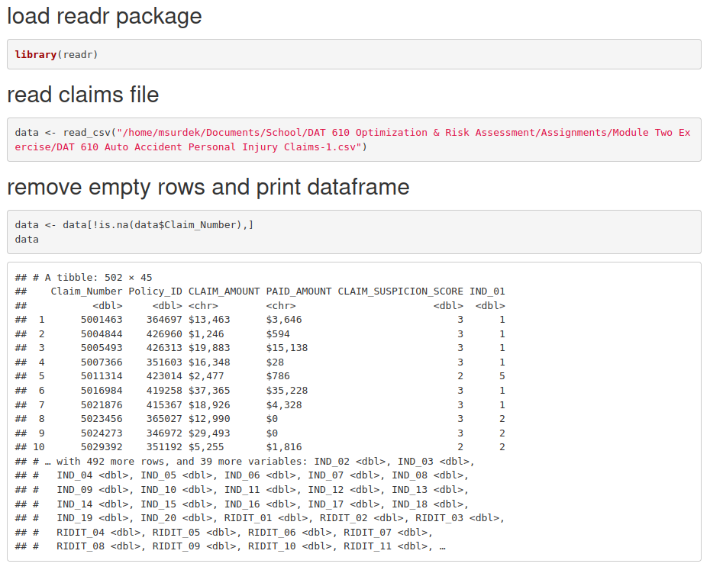
The first five elements of each observation are the claim number, the ID of the policy holder, the amounts that were claimed and ultimately paid, and a suspicion score ranging from 1 to 5. The next 20 attributes are indicative metrics, also ranging from 1 to 5, that quantify information such as vehicle and property damage. The last 20 attributes RIDIT-transformed versions of these indicative metrics. RIDIT transformations are a useful technique when values are quanitfied on a subjective scale. In these cases, the actual value of the variable is less important than its position in relation to the rest of the observations. By using the RIDIT approach, these metrics can be analyzed “based on the observed distribution of a response variable for a specified set of indivudals” (Bross), which allows for more accurate modelling and predictions.
Through more in-depth analysis in R, the claims file can be used to support risk identification and management of the seven categories of operational risk according to Basel II. These categories are internal fraud, external fraud, employment practices and workplace safety, clients, products, and business practices, damages to physical assets, business disruption and system failures, and execution, delivery, and process management. The category that would be best supported from this analysis is external fraud, which are “losses due to acts of a type intended to defraud, misappropriate property, or circumvent the law, by a third party.” (Girling) Company XYZ’s self-assessment of risk revealed that they are losing large amounts of money by paying out fraudelent auto accident claims. By analyzing the claims file, the company can improve their ability to identify and investigate the most suspicious claims and therefore lower their overall risk of external fraud. Additionally, this analysis can support their risk management for the categories of business practices, system failures, and process management. With a better process from top to bottom for identifying and investigating suspicious claims, Company XYZ can lower their risk of losses that might arise from failed processes, people, systems, and external events.
R is not only useful for statistical analysis, but it is also an excellent tool to integrate into Company XYZ’s enterprise data management framework. R includes the capabilities to develop accurate and complex models that quantify the chances of a particular claim being fraudelent. Based on the contents of the claims file, it is likely that 20 RIDIT-transformed metrics, or some combination of them that is determined algorithmically to be optimal, can serve as the foundation of a system that identifies potentially fraudelent claims. R is one of the best tools for developing this system, but the real benefits come from its capability to improve the business practices around claim identification and investiagtion. For example, it would be possible to automate the scheduling and assignments of the special investigations unit based on claims that are believed to be the most suspicious. They could even set up alerts for when potentially suspicious claims are entered into the system. Additonally, R is useful because it can handle information in real-time, meaning that as more information is revealed about each claim, the likelihood that it is fradulent can be updated accordingly, which would improve the abilities of the SIU as a whole.
References:

Bross, Irwin D. J. (1958). How to Use Ridit Analysis. Biometrics, 14(1), 18–38. Retrieved from https://doi.org/10.2307/2527727

Girling, P. X. (2013). Operational Risk Management: A Complete Guide to a Successful Operational Risk Framework. Wiley Professional Development (P&T). Retrieved from https://mbsdirect.vitalsource.com/books/9781118983430

